Course Syllabus
Principle and Practice of Global Innovation Teams

(A Pilot Course for the USC-PKU i-Podium™ Program)

Instructor:
Professor Stephen C-Y. Lu
David Packard Chair in Manufacturing Engineering;
Director, Product Development Engineering Program; and
Professor of Aerospace and Mechanical Engineering,
Computer Science, and Industrial and Systems Engineering

Office: Room 430H, Olin Hall of Engineering
Phone: 213-740-9616; Fax: 213-740-8071
Email: sclu@usc.edu; Website: http://wisdom.usc.edu/stephenlu

Course Section: XXX-31499

Course Unit: 3 units (2 hours per week for a total of 23 weeks)

Prerequisite: Undergraduate engineering students with good academic standing (students from other disciplines can only register with a special approval by the Instructor).

Class Hours: Tuesdays, 4:30pm to 6:30pm (California local time)
(Wednesdays, 7:30am to 9:30am – Beijing local time)

Class Location: OHE Room 100-C (USC DEN Studio)

Office Hours: 2:00pm to 4:00pm, on Tuesdays
- Face-to-face meetings held in 430H, OHE/USC
- Phone meetings via 213-740-9616
- Skype VoIP and/or video conference meetings can be arranged
(Email appointments/confirmations are required for all meetings.)

Teaching Assistant: Mr. Ang Liu
Office: BHE-B13; Email: angliu@usc.edu; phone: 213-740-9621
Office Hours: to be determined

Global Innovation Team Leader: Mr. Trent Bigelow
Email: trentbigelow@gmail.com; phone: 503-946-6209
- Background of the USC-PKU i-Podium™ Program

On May 27, 2009, USC’s Viterbi School of Engineering signed a Memorandum of Understanding (MoU) with the College of Engineering of Peking University in Beijing, China to establish a cooperative global engineering education program, called i-Podium™, between the two leading universities across the Pacific. The word “i” in this i-Podium™ program stands for international, innovative, interactive, immersive, integrated, interchange, and any combination of the above. Unlike conventional global education approaches that emphasize cross-discipline or current distance education activities that focus on cross-distance, the focal point of i-Podium™ is on the “cross-cultural” aspects of higher education. The program will utilize the state-of-the-art eLearning technology, but extends its present pedagogy, to provide a cross-cultural interactive learning environment for students to learn collaboratively with global community rather than study individually in isolation. Students from physically remote but digitally connected classrooms at USC and PKU can learn as cohorts in full synchronization and practice projects as teams in real and virtual environment on various socio-technical subjects whose solutions must include good understandings and considerations of different cultural and social factors. The goal of i-Podium™ is to experiment a new approach that can educate a different breed of globally-savvy engineering leaders of the 21st century who are not only competent as innovative system thinkers but also has true global perspectives with rich international experiences.

The first i-Podium™ pilot course to be offered in spring 2010, ENGR 499 (Principle and Practice of Global Innovation Teams), is specifically designed for the cross-cultural i-Podium™ global learning environment with the following special characteristics:

- The course subject is carefully chosen such that intensive, direct and continuous personal and group interactions, between USC and PKU students with various ethnic, cultural and social backgrounds, can make significant differences in their learning experiences on important technical subjects with significant global concerns.
- The course syllabus is purposefully developed so that both USC and PKU students can base from the same set of lecture materials in learning, but bring in different ethic-cultural-social viewpoints to case study and project work in practice. The course teaches students to learn engineering as a socio-technical discipline with cross-cultural emphases.
- The course delivery is strategically planned so that students from USC and PKU can synchronously and synergistically learn and work together as project teams in “one classroom from two locations”. It leads to a new frontier for existing distance education, because collaborative eLearning in a community always trumps remote study in isolation

- Three Learning Components: Classroom Lectures, Case Studies and Team Projects

Unlike traditional engineering courses that mainly focus on technical aspects of the subject, technological innovations are market-driven and inspired by emerging customer needs. As technology markets globalize, engineering students must have real experiences of global project teams to practice and understand the socio-technical dynamics of global innovation. Therefore, the i-Podium™ pilot course on Principle and Practice of Global Innovation Teams offers students three interrelated learning components: (1) classroom lectures on fundamental principles relate to technological innovation in light of rapid globalization, (2) case studies of technology/product/service examples to reveal cultural diversity as a key innovation catalyst, and (3) team projects to exercise global innovation by identifying new customer needs and functional requirements for technology/product/service developments. Upon completion of this course, students should be able to synthesize what they learn from lectures, cases and projects to competently participate in various technological innovation undertakings that explore cultural diversity as a unique source of innovation.

Among the three learning components, students’ active participation in team projects across cultural boundaries is the key feature and important highlight of this pilot course. Throughout the semester, USC and PKU students will work in small project teams to pursue global innovation opportunities inspired by cultural diversity among team members and based on the principles and cases learnt in the classroom. The course will have a specially designated “global innovation team leader” who brings in a rich set of international work experiences and innovation track records to assist the course instructor to provide direct coordination, supervision and mentorship to student teams in planning and execution of their projects. The i-Podium™ facility can support student teamwork in both synchronized and asynchronized modes. In addition to remote virtual interactions, the academic calendar difference between the two schools offers the unique opportunity for USC students to travel to PKU campus for on-site direct interactions with their PKU partners to complete and present the project work at the conclusion of their learning process (see next section for details). The mixed mode of virtual-real and remote-local interactions resembles the practice of global teams in international enterprises, and should give USC and PKU students a comprehensive experience in participating and leading cross-cultural engineering teamwork with global partners.

- The Course Structure and Organization

The “Principle and Practice of Global Innovation Teams” course will be offered at USC in spring semester 2010 (with extended period) as a general technical elective course (ISE499), in conjunction with a sister course simultaneously offered at PKU with separate course number designations. Professor Stephen Lu of the USC’s Viterbi School of Engineering is the course Instructor, who is only responsible for all learning activities and academic requirements of USC students. Although the two courses are closely related, USC and PKU students must register for the respective course number at their own campus. No cross-campus registration or auditing will be allowed. To ensure full and balanced team project participations among USC and PKU students, registration for this pilot course at USC for spring 2010 is only limited to 12 undergraduate engineering students (PKU also has its own registration restriction). The course will be delivered, and the required project work will be conducted, in English only throughout the semester.

The following table shows the comparative academic calendars of USC and PKU, and the corresponding course organization which offers three different modes of interaction.

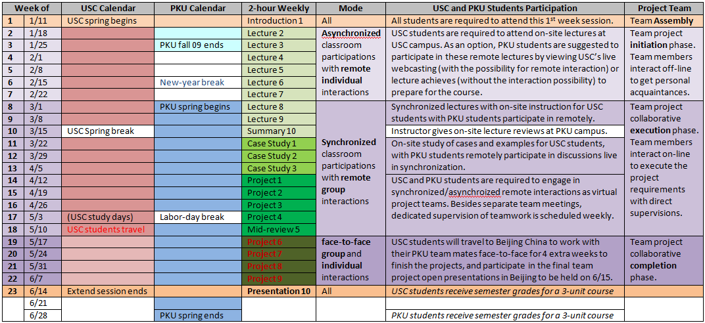

All USC and PKU students are required to attend the first week lecture which introduces the course subject and overall requirements. Team assembly among USC and PKU students will also begin in this week. During week 2 to week 7, when USC spring semester is in session and PKU students are finishing their fall 2009 semester and enjoying the Chinese lunar New Year break, the class will be conducted with asynchronized classroom participations and remote individual interactions between the two campuses. USC students are required to attend on-site lectures at USC campus. As an option, PKU students are suggested to participate in these remote lectures by viewing USC’s live webcasting (with the possibility for remote interaction) or lecture achieves (without the interaction possibility) to prepare for the course. During the same period, team members are encouraged to interact off-line to get better personal acquaintances of each others’ academic and social backgrounds. During week 8 to week 18, when both USC and PKU are in the spring semester, the class will be conducted with synchronized classroom participations with remote group interactions mode. Within these 11 weeks period, USC students will work with PKU students remotely, but interactively, through classroom lectures, discussions of case studies, and team projects. At the end of the 18th week, a midterm project review will be held before USC students travel to China to complete the project work. Lastly, during week 19 to week 24, the course will be conducted with the synchronized classroom participations with face-to-face group interactions mode. USC students who travel to PKU campus will continue working with their PKU teammates face-to-face for 4 extra weeks and participate in the final team project open presentations to be held on June 15, 2010 in Beijing. USC students will receive 3 units for this course at the end of the 23rd week.

- The Course Textbook and Reading Materials

The key focus of this course is on the cross-cultural aspects of engineering subjects with an emphasis on technological innovation in light of rapid globalization. Based on the belief that cultural understandings cannot be learnt from textbook (rather, it can be best acquired from studies of examples exercises of teamwork) and due to the broad scope and diverse coverage of this course, no required textbook or case study handbook is assigned. Instead, a variety of reference books will be recommended and periodic handouts will be given in the class.

- The Course Website

Students’ learning of this course is supplemented by a specially designed course website on the USC DEN Blackboard instruction system (https://www.uscden.net/webapps/login/). Note that this is not the general USC Blackboard website. All registered students have access to this website (ISE499_XXXX). The course website structure and contents are implemented to support the specific organization of the course learning components as described in this syllabus. All students should browse around the entire site to familiarize themselves with various areas and functions of this course website.

- Announcements – important announcements of this course (check it frequently)
- Course Information – syllabus; information about instructor; how to use this website; etc.
- Lecture Webcasting – recorded video files of each lecture
- Lecture Slides – PowerPoint slides of lecture notes
- Case Studies – assignments and information about your case studies
- Team Projects – assignments and information about your team projects
- Additional Readings – interesting articles that are related to the course subjects
- Resource Links – external links to websites that have relevant information to the course
- Communication – all communication tools, including emails and roster
- Discussion Board – share your thoughts about interesting subjects with the class
- Tools – other useful functions to manage your course work

- The Course Grading Scheme

Students will be graded according to the following grading scheme:

- 20% Participations in lectures and case study discussions
- 30% Two case study reports (15% each)
- 50% Team projects with PKU students

Note that 50% of your semester grade is based on the results of your project work, which is a team effort. All project work done by the team is first given a team grade. This team grade is then weighted for each student, based on confidential team self-evaluations by all team members at the end of the semester according to the following scheme:

Each student will be asked to fill out a questionnaire, which evaluates every team member (including him/herself) for the percentage contribution to the team project in different categories. The evaluations are averaged in order to find each student’s contribution and the weighting factor is made proportional to the average. For example, if you have three students on your team and each makes the same (33%) contribution, then all will get the same grade as the team grade. However, if one of your team members makes a 40% contribution, one a 25% contribution, and the third 35% contribution, then the individual grades will be corrected by the difference from 33%. Thus, if the team grade on your project presentation (or filed test, or product development file) is 85%, then the first student would get 92% (85 + (40-33)), the second would get 77% (85 + (25-33), and the third 87% (85 + (35-33)).

- The Course Lecture Subjects

The classroom lectures of this course on Principle and Practice of Global Innovation Teams will cover the following subject areas:

- An overview of technological innovation in the globalized world: challenges and opportunities for engineers
- What is globalization, and what are its impacts on economical and social progresses around the world?
- What is innovation, and what are its challenges and opportunities in light of rapid globalization?
- What is teamwork, and what are its roles and contributions in seizing the opportunities of global innovation?
- Putting all together: examples of global innovation teamwork applications in new product/system/service developments

- Case Studies and Discussions of Cross-Cultural Global Innovation

This section is to be completed later.

- The Global Innovation Team Projects Exercise

The experience gained from working in a global innovation team is the best way to develop good cross-cultural understandings in engineering. (More to be added by Trent Bigelow – the global innovation team leader of the course)

Academic Integrity:

"The Viterbi School of Engineering adheres to the University's policies and procedures governing academic integrity as described in SCampus. Students are expected to be aware of and to observe the academic integrity standards described in SCampus, and to expect those standards to be enforced in this course."

Students with Disabilities:

Any Student requesting academic accommodations based on a disability is required to register with Disability Services and Programs (DSP) each semester. A letter of verification for approved accommodations can be obtained from DSP. Please be sure the letter is delivered to me (or to TA) as early in the semester as possible. DSP is located in STU 301 and is open 8:30 a.m. - 5:00 p.m., Monday through Friday. The phone number for DSP is (213)740-0776.

